**What is redshift and recessional velocity in Astronomy?**

In the beginning of this universe, nearly fourteen billion years ago, you, me and everything we see around us from quarks to the big galaxies cluster in the space was concentrated in the volume less than one-trillionth the size of the letter that end this sentence. Conditions were so hot and dense, the basic forces of the nature that collectively defined the universe were unified.

But now our universe is so vast that every heavenly object in the space is either moving away or coming toward us.

The extragalactic objects that are moving apart from us are considered obeying the **redshift** and the objects that are moving away from us are considered obeying **blueshift**. This phenomenon of redshift and blueshift is collectively known as **doppler effect.**

But **what is exactly redshift how and why is it measured?**

Redshift is the ratio by which some object is moving away from other object in free space. It is measured by a standard formula:

$$Z = △λ/ λ$$

**△λ** stands for the difference in wavelength of the element observed in the spectrum and wavelength of the element calculated in laboratory (theoretical).

**λ** stands for the wavelength of the element calculated in laboratory.

**But from where we can observe the wavelength of the specific element in the extragalactic objects?**

If you take a spectrum of anything out in space, you will usually see spectral lines, caused by electrons jumping up and down energy levels and either emitting or absorbing light. Each element has characteristic wavelengths at which it produces lines: for example, the very famous H-alpha line of hydrogen occurs at 656.3nm wavelength. Here is the original observed spectrum of a AGN (Active galactic nuclei) galaxy from SDSS16:

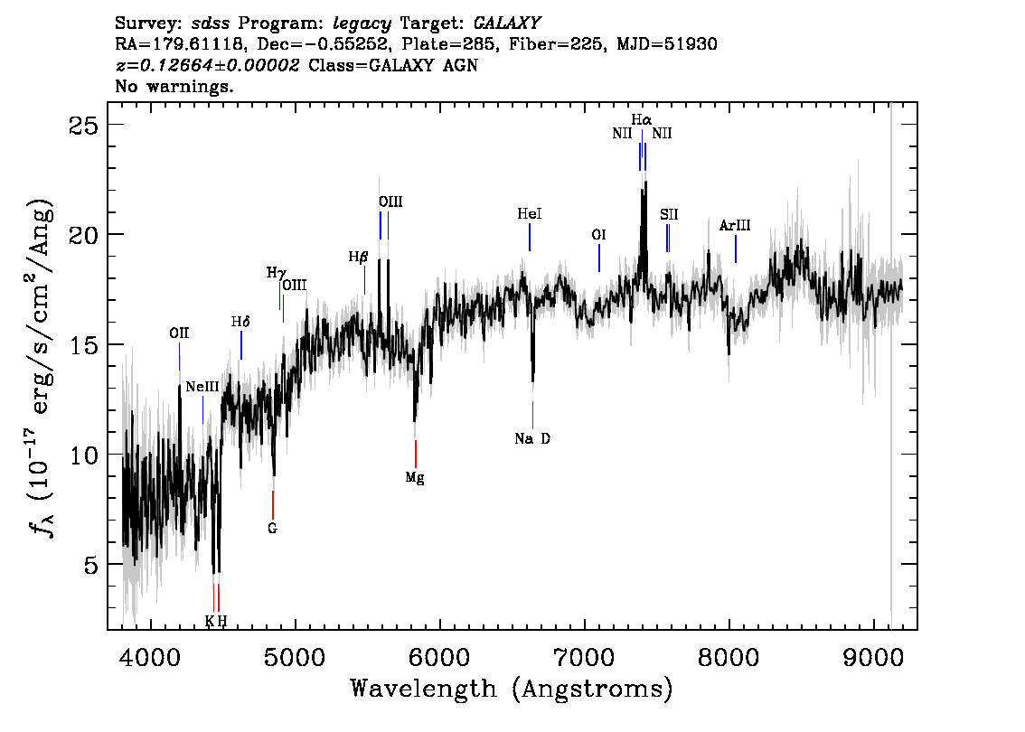

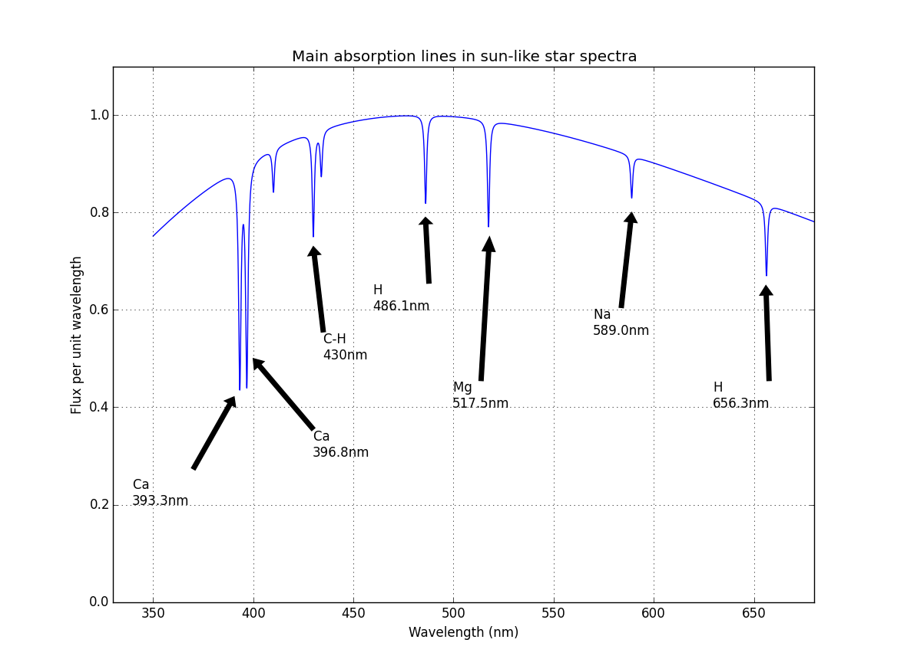Now if we compare observed spectrum we will observe H alpha absorption lines, is between 700-800 nm of the wavelength.

So here wavelength observed is nearly 739.5nm whereas theoretically the wavelength of the hydrogen is 656.3nm

Hence the redshift here is:

**Z = 83.2/656.3 ~ 0.126**

But here we stand by with a ratio of two wavelengths but how do we know how this star is moving farther, for that we need to find its **recessional velocity (v) = redshift × speed of light** *(recessional velocity is the velocity with which an object in space move away from us.*)

Which implies the recessional velocity of this galaxy is **300000 × 0.126 = 3,80,31.388 km/s** which is a lot.

Edwin Hubble showed that the recession velocity is proportional to distance: i.e., that

$$v = HoD$$

, where is $Ho$ Hubble's constant and has a value of around **70 km/s/MPc** (i.e., a galaxy that is one mega-parsec from us is moving away at a speed of around 70 km/s). Does this mean we are in a special place and everything is moving away from us? No - using vectors you can show that you would see exactly the same thing wherever you are. So - we live in a uniform and seemingly endless

universe, and wherever you are in this universe, everything seems to be moving away from you with a velocity proportional to its distance.

**~Jashanpreet Singh Dingra**

[astrodingra@gmail.com](mailto:astrodingra@gmail.com)

<https://jsdingra.github.io>